**WEB APPLICATION DEVELOPMENT LAB**

**27-02-2025**

Eshwar Deshmukh Chavan

HU22CSEN0100999

1.Create object from JSON String for student data like pin, first name, last name, course, cgpa.

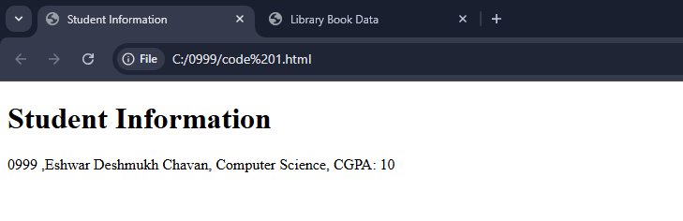

<!DOCTYPE html>

<html lang="en">

<head>

<meta charset="UTF-8">

<meta name="viewport" content="width=device-width, initial-scale=1.0">

<title>Student Information</title>

</head>

<body>

<h1>Student Information</h1>

<div id="student-info"></div>

<script>

const jsonString = '{"pin": "0999", "firstname": "Eshwar", "lastname": "Deshmukh Chavan", "course": "Computer Science", "cgpa": 10}';

class Student {

constructor(pin, firstname, lastname, course, cgpa) {

this.pin = pin;

this.firstname = firstname;

this.lastname = lastname;

this.course = course;

this.cgpa = cgpa;

}

display() {

return `${this.pin} ,${this.firstname} ${this.lastname}, ${this.course}, CGPA: ${this.cgpa}`;

}

}

const studentData = JSON.parse(jsonString);

const student = new Student(studentData.pin, studentData.firstname, studentData.lastname, studentData.course, studentData.cgpa);

document.getElementById('student-info').innerText = student.display();

</script>

</body>

</html>

2.Write a program to maintain library book data by using join and java script.

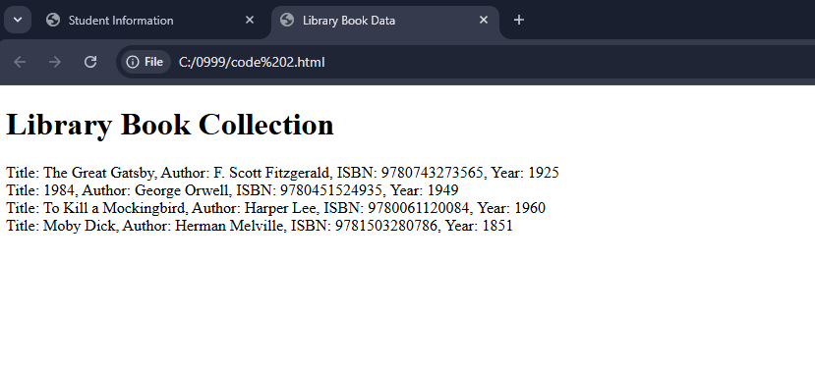<!DOCTYPE html>

<html lang="en">

<head>

<meta charset="UTF-8">

<meta name="viewport" content="width=device-width, initial-scale=1.0">

<title>Library Book Data</title>

</head>

<body>

<h1>Library Book Collection</h1>

<div id="library"></div>

<script>

const books = [

{ title: "The Great Gatsby", author: "F. Scott Fitzgerald", isbn: "9780743273565", year: 1925 },

{ title: "1984", author: "George Orwell", isbn: "9780451524935", year: 1949 },

{ title: "To Kill a Mockingbird", author: "Harper Lee", isbn: "9780061120084", year: 1960 },

{ title: "Moby Dick", author: "Herman Melville", isbn: "9781503280786", year: 1851 }

];

const bookDetails = books.map(book => {

return `Title: ${book.title}, Author: ${book.author}, ISBN: ${book.isbn}, Year: ${book.year}`;

}).join('<br>');

document.getElementById('library').innerHTML = bookDetails;

</script>

</body>

</html>